ASSIGNMENT 1
Identify the Association Between Dependent and Independent Variables

1. Aim and Practical Objectives
To investigate, quantify and model the association between independent (predictor) variables and a continuous dependent (response) variable using a real-world multivariate dataset.
- Visualise relationships using scatterplots and a correlation heatmap.
- Measure strength and direction of association using Pearson and Spearman correlation.
- Model the relationship using simple and multiple linear regression.
- Check multicollinearity (VIF) and residual assumptions, then interpret the results.

2. Theory

2.1 Dependent and independent variables
In a data set, an independent variable (also called a predictor, explanatory variable or feature) is a variable whose value is used to explain or predict another variable. The dependent variable (also called the response or target) is the outcome whose value depends on the predictors. For example, in a study of house prices, the area, number of rooms and age of the house are independent variables, while the price is the dependent variable. Studying the association between them means measuring how strongly, in which direction and in what form the dependent variable changes when the independent variables change.
An association is a statistical relationship between two variables. It does not prove causation: two variables can move together because of a third (confounding) variable or by coincidence. Association analysis is therefore the first step of any predictive modelling task, because it shows which features are worth using.

2.2 Covariance and correlation
Covariance measures whether two variables increase together (positive) or in opposite directions (negative). Its size depends on the units of the variables, so it is hard to interpret directly.
Cov(X, Y) = Σ (xᵢ − x̄)(yᵢ − ȳ) / (n − 1)
The Pearson correlation coefficient r standardises covariance by the standard deviations sₓ and s_y, so that it always lies between −1 and +1. It measures the strength and direction of a linear relationship.
r = Cov(X, Y) / (sₓ · s_y)
Value of |r| | Strength of linear association
0.00 - 0.19 | Very weak / negligible
0.20 - 0.39 | Weak
0.40 - 0.59 | Moderate
0.60 - 0.79 | Strong
0.80 - 1.00 | Very strong

Pearson correlation assumes that the variables are continuous, the relationship is linear and there are no extreme outliers. To test whether the observed correlation is real or due to chance, the statistic t = r√(n−2) / √(1−r²) is compared with a t distribution with n − 2 degrees of freedom. A small p-value (usually below 0.05) means the correlation is statistically significant.

2.3 Spearman rank correlation
Spearman's coefficient ρ is the Pearson correlation computed on the ranks of the data instead of the raw values. It detects any monotonic relationship (always increasing or always decreasing, not necessarily a straight line) and is less affected by outliers and skewed data. When there are no tied ranks it can be written as:
ρ = 1 − 6 Σ dᵢ² / ( n (n² − 1) ) where dᵢ = difference between the ranks of xᵢ and yᵢ
If Pearson and Spearman values are close, as in this practical, the relationship is mostly linear. If Spearman is much larger than Pearson, the relationship is monotonic but curved.

2.4 Simple linear regression
Regression goes one step beyond correlation: it builds an equation that predicts the dependent variable from the independent variable. Simple linear regression uses a single predictor:
y = β₀ + β₁ x + ε
β₀ is the intercept, β₁ is the slope (the average change in y for a one-unit increase in x) and ε is the random error. The coefficients are found by the method of least squares, which minimises the sum of squared errors SSE = Σ(yᵢ − ŷᵢ)². The goodness of fit is measured by the coefficient of determination R² = 1 − SSE/SST, the proportion of the variance of y explained by the model. For simple regression R² equals r².

2.5 Multiple linear regression
When several predictors are used together, the model becomes:
y = β₀ + β₁x₁ + β₂x₂ + … + βₚxₚ + ε
In matrix form the least-squares solution is β̂ = (XᵀX)⁻¹ Xᵀy. Each coefficient βⱼ is interpreted as the change in y for a one-unit change in xⱼ while all other predictors are held constant. This is why a variable can look unimportant on its own but become significant in the multiple model, or the reverse. Because R² never decreases when a variable is added, the adjusted R² = 1 − (1 − R²)(n − 1)/(n − p − 1) is used to compare models with different numbers of predictors. The overall significance of the model is tested with the F-test, and the significance of each coefficient with a t-test.

2.6 Multicollinearity and the Variance Inflation Factor
Multicollinearity occurs when independent variables are strongly correlated with each other. It does not reduce the predictive power of the model as a whole, but it makes the individual coefficients unstable, inflates their standard errors and can even flip their signs. The Variance Inflation Factor measures how much the variance of a coefficient is inflated:
VIFⱼ = 1 / (1 − Rⱼ²) (Rⱼ² = R² of regressing xⱼ on all the other predictors)
A VIF of 1 means no collinearity; values above 5 indicate a concern and values above 10 indicate serious multicollinearity. Remedies include removing or combining correlated variables, principal component analysis, or regularisation (Ridge or Lasso).

2.7 Assumptions and diagnostics of linear regression
- Linearity: the relationship between predictors and the target is linear (checked with scatterplots and the residual-vs-fitted plot).
- Independence: the errors are independent of each other.
- Homoscedasticity: the errors have constant variance (the residual plot should show an even band without a funnel shape).
- Normality of residuals: the errors are approximately normally distributed (checked with a Q-Q plot and the Shapiro-Wilk test).
- No severe multicollinearity among the predictors (checked with VIF).

2.8 Applications
Association analysis and regression are used for house-price prediction, sales forecasting from advertising spend, medical risk factor studies, salary analysis, demand estimation and any problem where it is important to know which factors influence an outcome and by how much.

2.9 Worked example (small data set)
Consider five observations of a predictor x and a target y: (1, 2), (2, 4), (3, 5), (4, 4), (5, 5). The means are x̄ = 3 and ȳ = 4. The sums needed are Σ(x − x̄)(y − ȳ) = 6, Σ(x − x̄)² = 10 and Σ(y − ȳ)² = 6.
r = 6 / √(10 × 6) = 6 / 7.746 = 0.775 slope β₁ = 6 / 10 = 0.6 R² = r² = 0.60
The correlation is strong and positive. However, the t-statistic is t = 0.775 × √3 / √(1 − 0.60) = 2.12 with 3 degrees of freedom, which gives a p-value of about 0.12, so with only five observations the correlation is not statistically significant. This shows why the sample size matters: the same r would be highly significant with a few hundred observations, as in the practical below.

3. Dataset Description
The Diabetes dataset (Efron et al., 2004) from scikit-learn is used: 442 patients, no missing values. Dependent variable (Y): target, a measure of disease progression one year after baseline. Independent variables (X) are ten baseline measurements, mean-centred and scaled: age, sex, bmi (body mass index), bp (average blood pressure), s1 (total cholesterol), s2 (LDL), s3 (HDL), s4 (total cholesterol/HDL ratio), s5 (log serum triglycerides) and s6 (blood sugar).

4. Procedure
Load the data and check for missing values; compute Pearson and Spearman correlations with p-values; draw scatterplots and a heatmap; fit simple regression for each predictor and a multiple regression using all predictors; check VIF and residuals (residual plot, Q-Q plot, Shapiro-Wilk test); interpret the findings.

5. Observations and Results

5.1 Summary of association between predictors and the target
Predictor | Pearson r | Spearman rho | Simple R² | Multiple coef. | Multiple p | VIF
age | 0.188 | 0.198 | 0.035 | -10.01 | 0.867 | 1.22
sex | 0.043 | 0.037 | 0.002 | -239.82 | <0.001 | 1.28
bmi | 0.586 | 0.561 | 0.344 | 519.85 | <0.001 | 1.51
bp | 0.441 | 0.416 | 0.195 | 324.38 | <0.001 | 1.46
s1 | 0.212 | 0.232 | 0.045 | -792.18 | 0.058 | 59.2
s2 | 0.174 | 0.196 | 0.03 | 476.74 | 0.160 | 39.19
s3 | -0.395 | -0.41 | 0.156 | 101.04 | 0.635 | 15.4
s4 | 0.43 | 0.449 | 0.185 | 177.06 | 0.273 | 8.89
s5 | 0.566 | 0.589 | 0.32 | 751.27 | <0.001 | 10.08
s6 | 0.382 | 0.351 | 0.146 | 67.63 | 0.306 | 1.48
Table 1: Correlation, simple regression, multiple regression and VIF for each predictor
Multiple regression fit: R² = 0.518, adjusted R² = 0.507, F = 46.27 (p < 0.001), RMSE = 53.48. The significant predictors (p < 0.05) are bmi, bp, s5 and sex. s1 to s5 have VIF values up to 59 (above 10 is serious), so their individual coefficients are unstable even though they correlate with the target.

5.2 Visual association
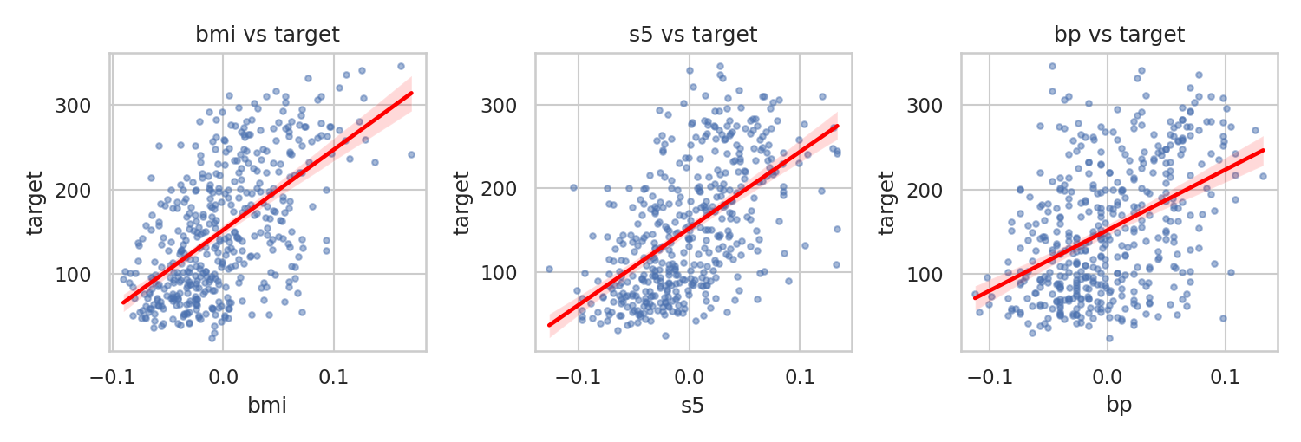
Figure 1: bmi, s5 and bp against the target, with fitted lines. All show a positive linear trend.
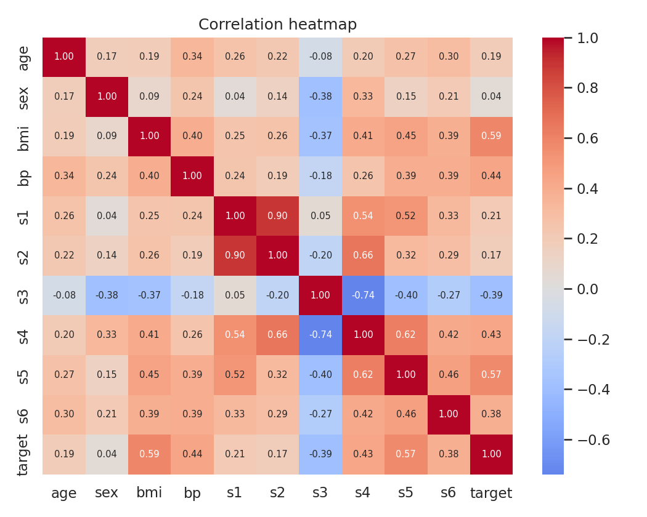  Figure 2: Correlation heatmap | Key observations  - bmi (r = 0.586) and s5 (r = 0.566) show the strongest positive association with the target.  - s3 (HDL) is the only notable negative association (r = -0.395).  - sex has no significant relation on its own (p = 0.366).  - s1, s2, s3, s4 and s5 are highly inter-correlated, which signals multicollinearity.  - Spearman values are close to Pearson values, so the relations are mostly linear/monotonic.

5.3 Residual diagnostics
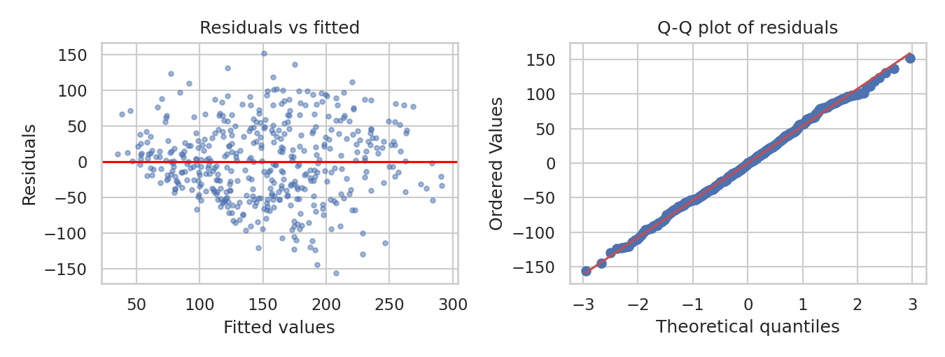
Figure 3: Residual plot and Q-Q plot. Residuals are spread evenly around zero and follow the line; Shapiro-Wilk W = 0.9971, p = 0.616, so normality is not rejected.

5.4 Summary of key findings
Finding | Evidence from the output
Strongest linear associations with target | bmi (r = 0.586), s5 (r = 0.566), bp (r = 0.441)
Only notable negative association | s3 (HDL): r = -0.395
Multiple regression fit | R² = 0.518, adjusted R² = 0.507, F = 46.27 (p < 0.001)
Significant predictors (p < 0.05) | bmi, bp, s5 and sex
Multicollinearity | VIF: s1 = 59.2, s2 = 39.2, s3 = 15.4, s5 = 10.1
Residual normality | Shapiro-Wilk W = 0.9971, p = 0.616 (normality not rejected)
Table 2: Summary of the main findings of this practical

6. Python Source Code Implementation
The complete Python code used for the analysis is given below:

import numpy as np
import pandas as pd
import matplotlib.pyplot as plt
import seaborn as sns
from scipy import stats
from sklearn.datasets import load_diabetes

# ------------------------------------------------------------------------
# 1. Load the dataset
# ------------------------------------------------------------------------
df = load_diabetes(as_frame=True).frame
y = df["target"]
X = df.drop(columns="target")
print("=== DATASET OVERVIEW ===")
print("Shape:", df.shape, "| Missing values:", df.isna().sum().sum())

# ------------------------------------------------------------------------
# 2. Pearson, Spearman correlation and simple regression with the target
# ------------------------------------------------------------------------
rows = []
for c in X.columns:
pr, pp = stats.pearsonr(X[c], y)
sr, sp = stats.spearmanr(X[c], y)
lr = stats.linregress(X[c], y)
rows.append([c, pr, pp, sr, sp, lr.rvalue ** 2])

corr = pd.DataFrame(rows, columns=["Predictor", "Pearson_r", "Pearson_p",
"Spearman_rho", "Spearman_p", "Simple_R2"])
print("\n=== CORRELATION AND SIMPLE REGRESSION (TARGET: disease progression) ===")
print(corr.to_string(index=False, float_format=lambda v: f"{v:.3g}"))

# ------------------------------------------------------------------------
# 3. Multiple linear regression (all predictors together)
# ------------------------------------------------------------------------
A = np.column_stack([np.ones(len(X)), X.values]) # add intercept column
names = ["Intercept"] + list(X.columns)

beta = np.linalg.lstsq(A, y.values, rcond=None)[0] # least-squares coefficients
res = y.values - A @ beta # residuals
n, k = A.shape
s2 = res @ res / (n - k)
se = np.sqrt(np.diag(s2 * np.linalg.inv(A.T @ A))) # standard errors
t = beta / se
p = 2 * (1 - stats.t.cdf(np.abs(t), n - k))

model = pd.DataFrame({"Term": names, "Coef": beta, "Std_err": se,
"t": t, "p_value": p})
print("\n=== MULTIPLE LINEAR REGRESSION ===")
print(model.to_string(index=False, float_format=lambda v: f"{v:.3f}"))

sst = ((y - y.mean()) ** 2).sum()
r2 = 1 - (res @ res) / sst
adj_r2 = 1 - (1 - r2) * (n - 1) / (n - k)
F = ((sst - res @ res) / (k - 1)) / s2
print(f"R-squared: {r2:.3f} | Adj. R-squared: {adj_r2:.3f}")
print(f"F-statistic: {F:.2f} | RMSE: {np.sqrt(res @ res / n):.2f}")

# ------------------------------------------------------------------------
# 4. Multicollinearity check: Variance Inflation Factor (VIF)
# ------------------------------------------------------------------------
vif = []
for c in X.columns:
others = np.column_stack([np.ones(len(X)), X.drop(columns=c).values])
b = np.linalg.lstsq(others, X[c].values, rcond=None)[0]
r2_c = 1 - ((X[c].values - others @ b) ** 2).sum() / ((X[c] - X[c].mean()) ** 2).sum()
vif.append([c, 1 / (1 - r2_c)])

print("\n=== VARIANCE INFLATION FACTOR (VIF) ===")
print(pd.DataFrame(vif, columns=["Predictor", "VIF"]).round(2).to_string(index=False))

# ------------------------------------------------------------------------
# 5. Residual normality test (Shapiro-Wilk)
# ------------------------------------------------------------------------
W, p_sw = stats.shapiro(res)
print("\n=== RESIDUAL NORMALITY (SHAPIRO-WILK) ===")
print(f"W = {W:.4f} | p-value = {p_sw:.3f}")
print("Residuals look normal" if p_sw > 0.05 else "Residuals are not normal")

# ------------------------------------------------------------------------
# 6. Visualisations
# ------------------------------------------------------------------------
fig, axs = plt.subplots(1, 3, figsize=(10, 3.4)) # scatterplots
for ax, c in zip(axs, ["bmi", "s5", "bp"]):
sns.regplot(x=X[c], y=y, ax=ax, line_kws={"color": "red"})
plt.show()

sns.heatmap(df.corr(), annot=True, fmt=".2f", cmap="coolwarm", center=0)
plt.show() # correlation heatmap

fig, axs = plt.subplots(1, 2, figsize=(9, 3.4)) # residual plots
axs[0].scatter(A @ beta, res)
axs[0].axhline(0, color="red")
stats.probplot(res, plot=axs[1])
plt.show()

7. Execution Output
The output obtained on executing the script (Section 5 is based on it):

=== DATASET OVERVIEW ===
Shape: (442, 11) | Missing values: 0

=== CORRELATION AND SIMPLE REGRESSION (TARGET: disease progression) ===
Predictor Pearson_r Pearson_p Spearman_rho Spearman_p Simple_R2
age 0.188 7.06e-05 0.198 2.81e-05 0.0353
sex 0.0431 0.366 0.0374 0.433 0.00185
bmi 0.586 3.47e-42 0.561 4.57e-38 0.344
bp 0.441 1.65e-22 0.416 5.99e-20 0.195
s1 0.212 6.92e-06 0.232 7.79e-07 0.045
s2 0.174 0.000236 0.196 3.39e-05 0.0303
s3 -0.395 6.16e-18 -0.41 2.38e-19 0.156
s4 0.43 2.3e-21 0.449 2.63e-23 0.185
s5 0.566 8.83e-39 0.589 1.07e-42 0.32
s6 0.382 7.58e-17 0.351 3.03e-14 0.146

=== MULTIPLE LINEAR REGRESSION ===
Term Coef Std_err t p_value
Intercept 152.133 2.576 59.061 0.000
age -10.010 59.749 -0.168 0.867
sex -239.816 61.222 -3.917 0.000
bmi 519.846 66.533 7.813 0.000
bp 324.385 65.422 4.958 0.000
s1 -792.176 416.680 -1.901 0.058
s2 476.739 339.030 1.406 0.160
s3 101.043 212.531 0.475 0.635
s4 177.063 161.476 1.097 0.273
s5 751.274 171.900 4.370 0.000
s6 67.627 65.984 1.025 0.306
R-squared: 0.518 | Adj. R-squared: 0.507
F-statistic: 46.27 | RMSE: 53.48

=== VARIANCE INFLATION FACTOR (VIF) ===
Predictor VIF
age 1.22
sex 1.28
bmi 1.51
bp 1.46
s1 59.20
s2 39.19
s3 15.40
s4 8.89
s5 10.08
s6 1.48

=== RESIDUAL NORMALITY (SHAPIRO-WILK) ===
W = 0.9971 | p-value = 0.616
Residuals look normal

8. Interpretation and Conclusion
- Disease progression is clearly associated with several predictors; bmi, s5 (triglycerides) and bp are the most important, and s3 (HDL) is negatively associated.
- Correlation shows association, not causation. Single-variable views can mislead (for example sex), so multivariate modelling is needed.
- The multiple regression explains about 52% of the variance (adjusted R² = 0.507). Residuals are approximately normal, but strong multicollinearity among s1 to s5 means those coefficients should be interpreted cautiously.
Conclusion: the practical identified and quantified the association between the independent variables and the dependent variable. bmi, bp, s5 and sex are significant predictors in the multiple model. Regularisation (Ridge/Lasso) or feature selection could improve the model in future work.
- Limitations: the data set has only 442 patients and the predictors are standardised, so the coefficients are not in original units; linear models cannot capture non-linear effects.
- Future scope: apply Ridge or Lasso to handle multicollinearity, add interaction or non-linear terms, and validate the model on a separate test set.

9. Key Terms and Definitions
Term | Meaning
Dependent variable | The outcome being explained or predicted (target)
Independent variable | A predictor used to explain the dependent variable
Pearson correlation (r) | Strength and direction of a linear relationship, from -1 to +1
Spearman correlation (ρ) | Correlation of ranks; measures any monotonic relationship
p-value | Probability of seeing such a result by chance; below 0.05 is usually called significant
R-squared | Share of the variance of the target explained by the model
VIF | Variance Inflation Factor; values above 10 signal serious multicollinearity
Reference: Efron, B., Hastie, T., Johnstone, I. and Tibshirani, R. (2004). Least Angle Regression. Annals of Statistics, 32(2), 407-499.

